**TestLink User Guide**

Table of Contents

Introduction: 1

TestLink Dashboard: 1

User & Role Management 1

Project Management 5

Test Plan & Build Management 7

Test Case Management – Test Specification 8

Test Execution Management 12

Test Reports 15

# Introduction:

TestLink is a test management tool used to track and maintain the records of all STLC phases starting from the Test Plan to the Report Creation phase.

## TestLink Dashboard:

When a user logs in to the application, they are navigated to the Dashboard page of the TestLink application. Here all the Menu options are displayed to the user.

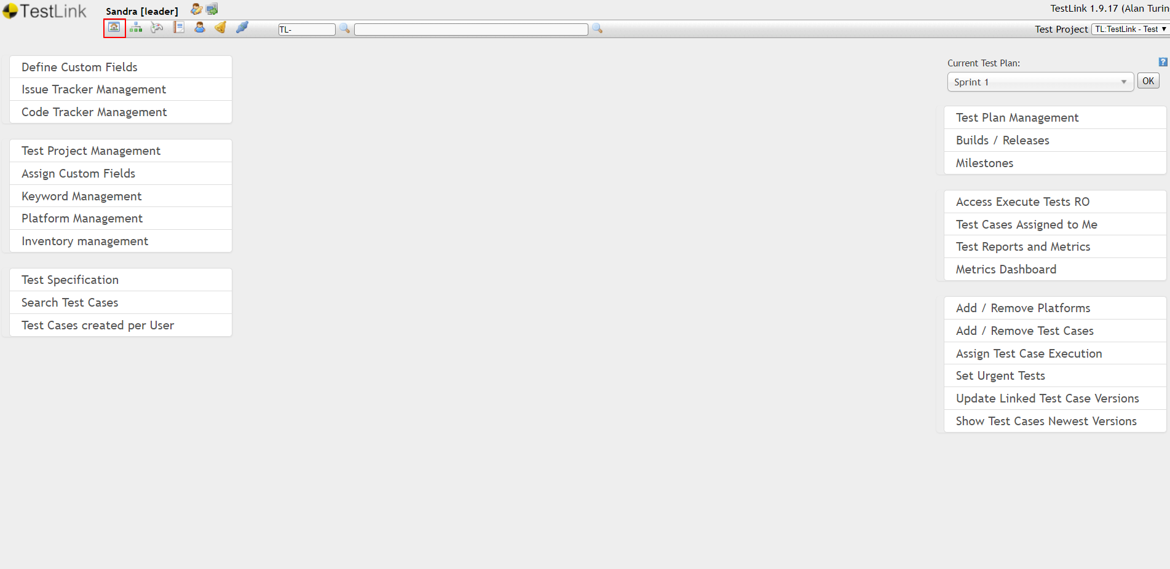

If the user is on any other page, by clicking on the highlighted icon user can re-navigate to the Dashboard Page.

### User & Role Management

##### Roles & Permissions in TestLink

Following are the list of default roles that are currently available

1. <reserved system role 1> - System generated user role with no permissions
2. <reserved system role 2> - System generated user role with no permissions
3. <no rights> - System generated user role with no permissions
4. test designer – Can create and manage test cases, requirements and keywords
5. guest – Can view test reports & metrics and test cases
6. senior tester – Can add/edit/view/execute test plans, test cases. Add requirements and keywords.
7. tester – Can view and execute test plans, test cases
8. admin – Has all available permissions
9. leader – Has all available permissions

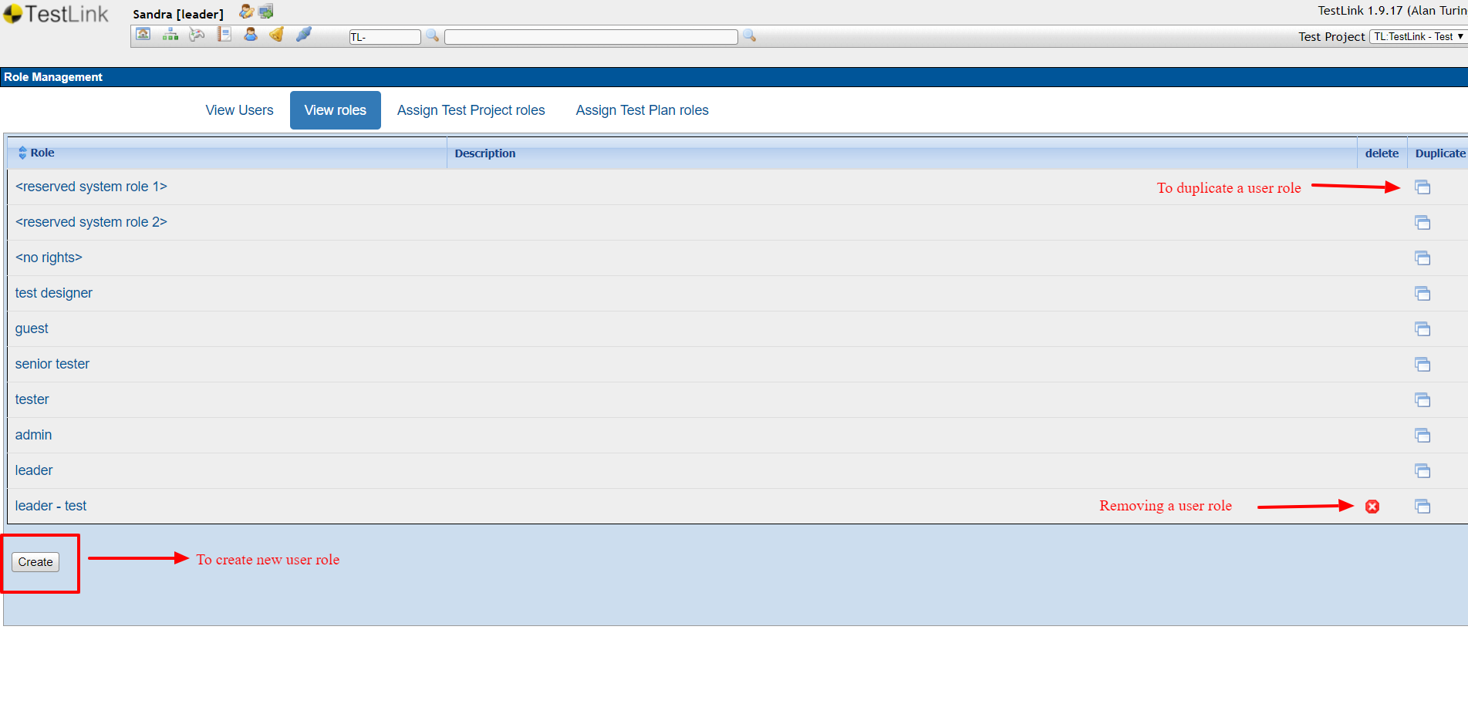

The ‘leader - test’ user role was duplicated and created. User roles can be deleted/removed only if it was duplicated or created by a user, that’s why only the ‘leader - test’ user role has a delete/remove user role option.

Permissions in TestLink are as displayed below

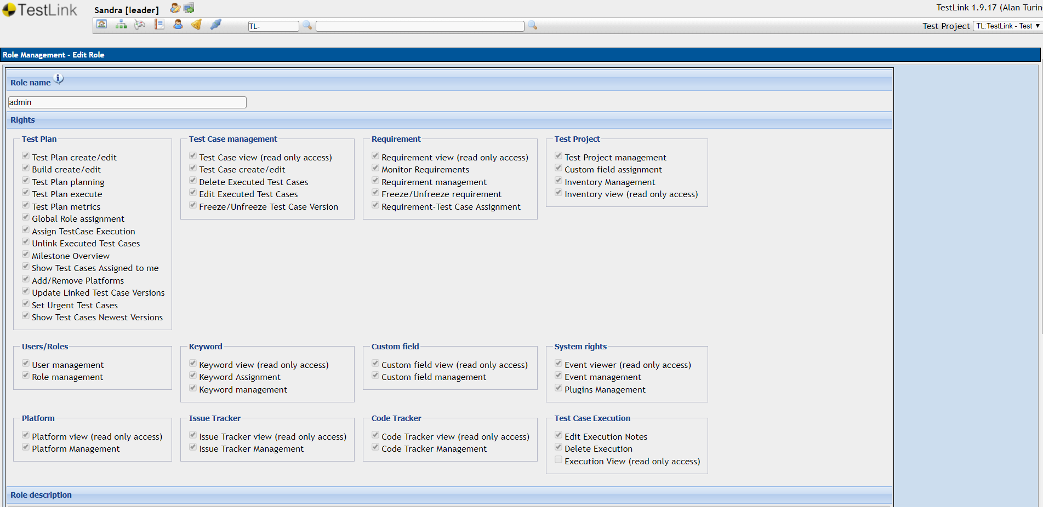

##### Creating Users and Assigning Roles

User creation menu will be displayed to the logged-in user based on the role assigned and permissions provided.

Logged-in user should have the following permissions to access User Management

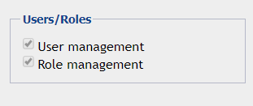

On having the above permission, user will be able to see the following icon in their shortcut menu

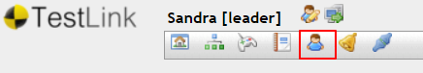

The list of available users and their Add/Edit/Delete options will be displayed on click of the above icon

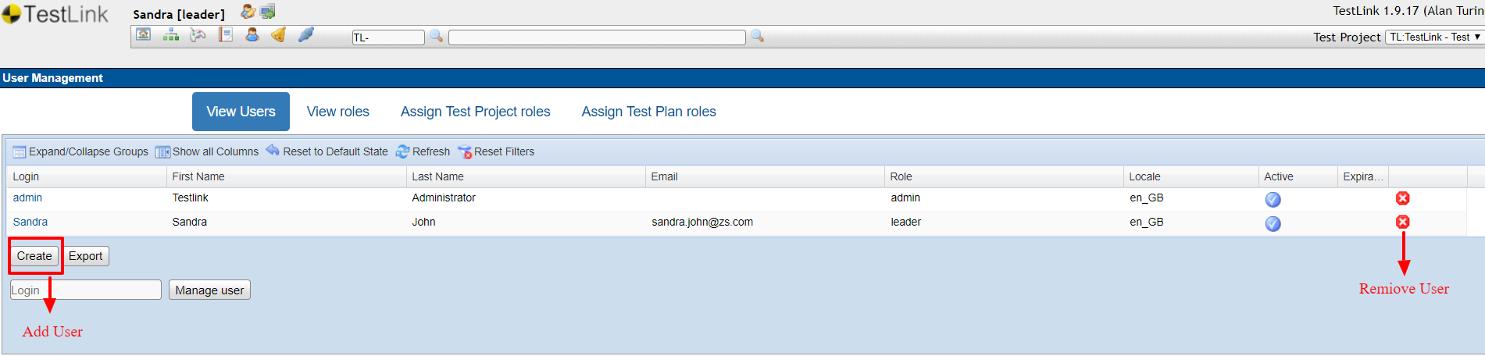

To edit a user, insert the Login name of the user and click on the ‘**Manage user**’ button, the user will be then navigated to the Edit user form, which is like the ‘**Add User**’ form

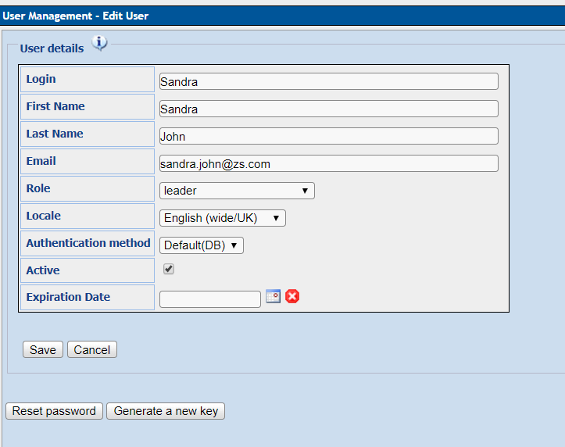

User’s role can be changed as per the Test Project or a specific Test Plan. For a user role changes as per the Test Project, can be only done by an **admin** user role.

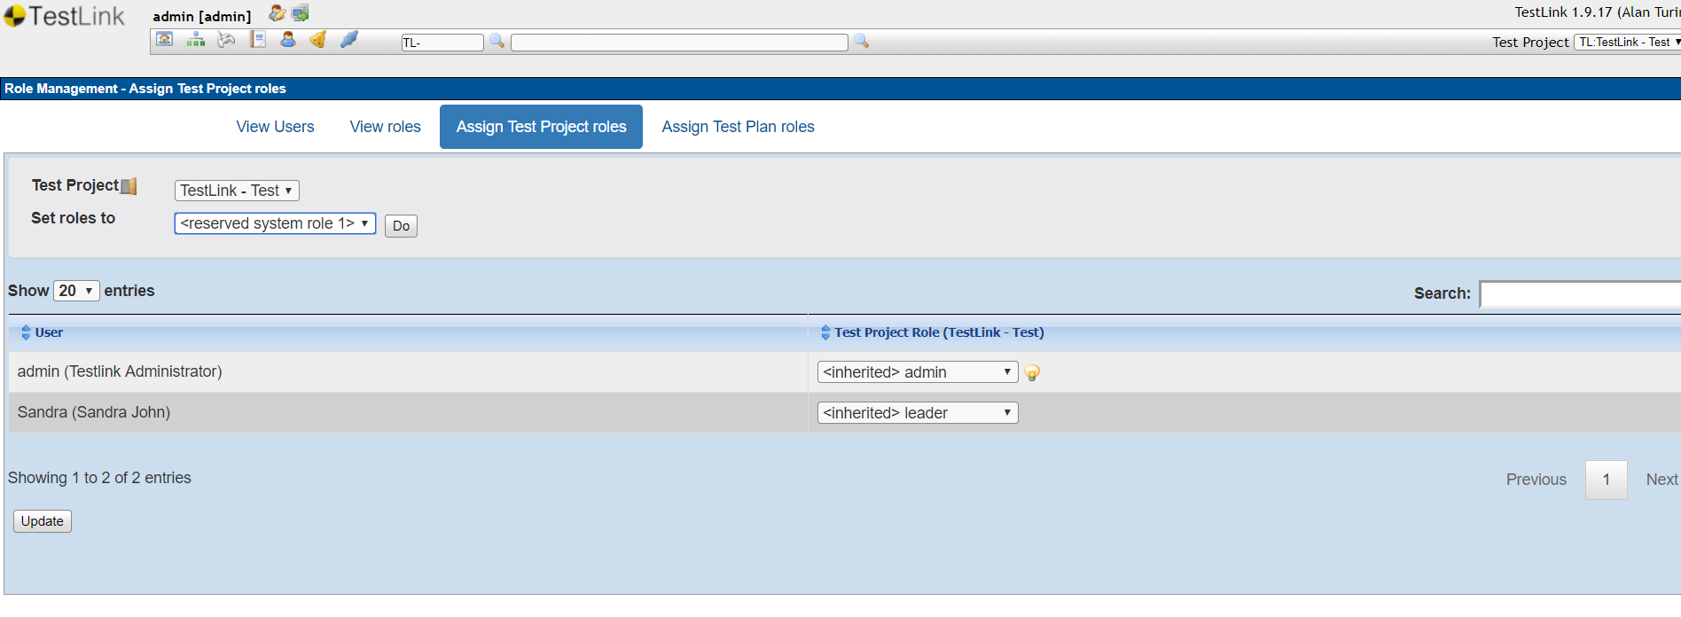

User role management as per Test Plan

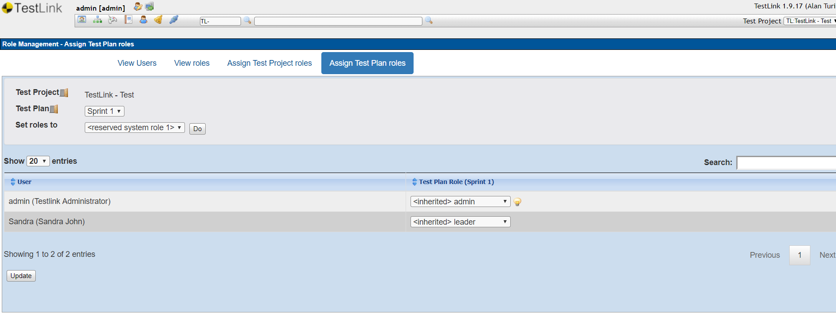

### Project Management

To manage projects, the logged-in user must have the following permissions

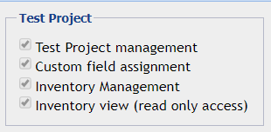

When the logged-in user has the required permission, following **Test Project Management** will be displayed in the menu options to the user

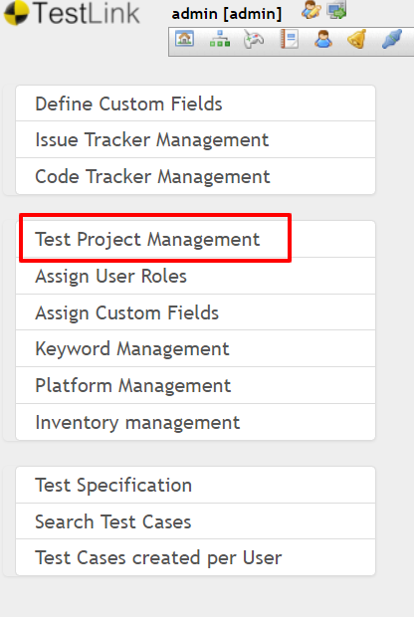

On navigating to the Test Project Management page, following is displayed

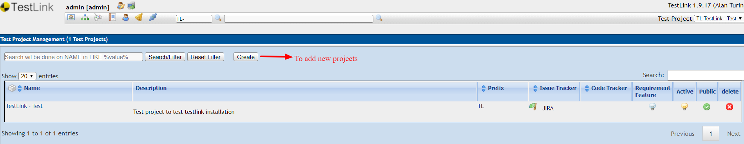

While creating a project, the following need to be configured, as displayed in the image.

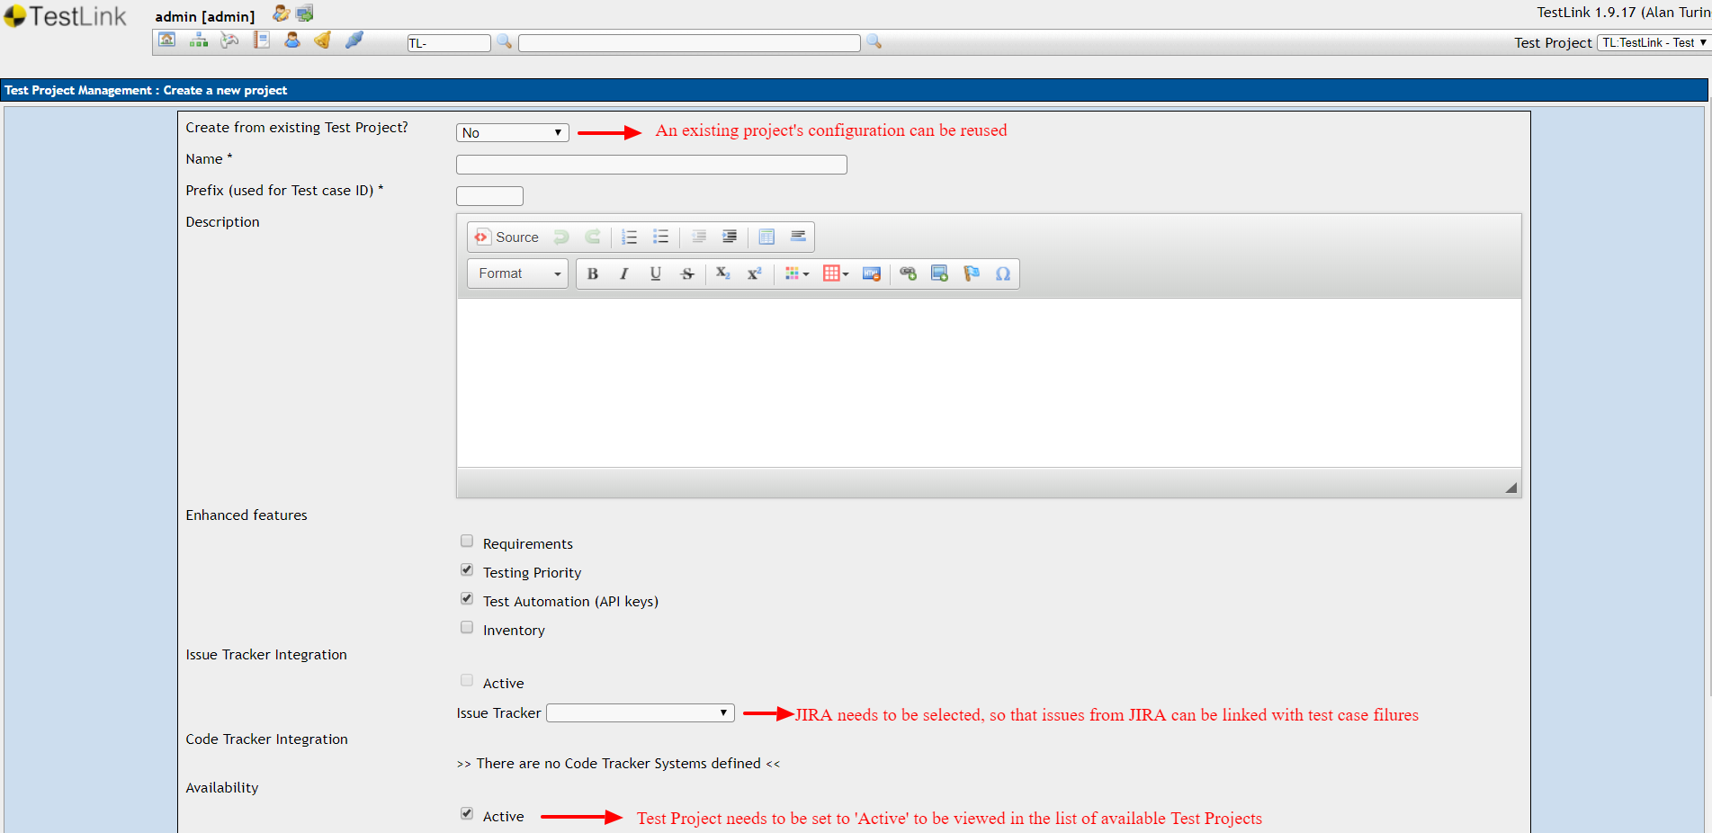

After updating the required fields and clicking on ‘**Create**’ the project will start displaying in the ‘**Test Project**’ dropdown.

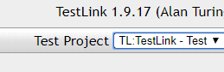

### Test Plan & Build Management

User role Permission needed

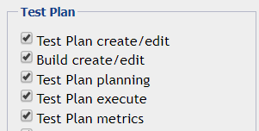

On the Dashboard page, user will be displayed the following menu options

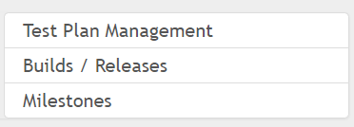

On click of the ‘**Test Plan Management**’, user will be navigated to the Test Plan Management screen. From here the user can add/edit/delete Test Plans for a project

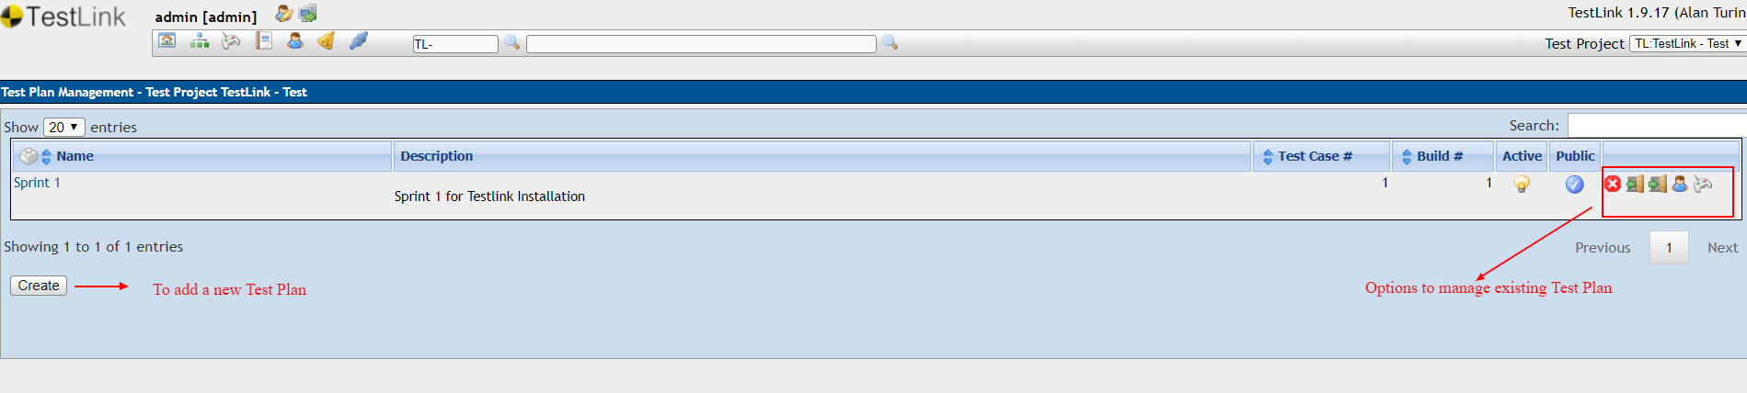

Similarly, to add a Build, user needs to click on the ‘**Build / Releases**’ menu option. On clicking it, user will be navigated to the Build Management screen. From here, the user can add/edit/delete Builds for a project.

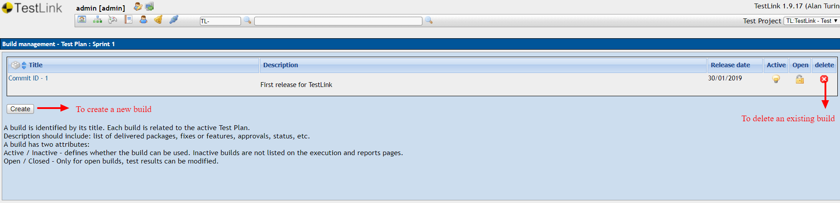

### Test Case Management – Test Specification

Test Specification defines the structure of Test Design. Creation of Test Suits and Cases are done through test specification. However, one project can have only one test specification. Test Specification can be accessed by navigating to Test Specification → Test Specification from the dashboard.

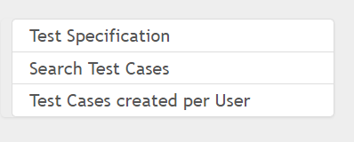

It is divided into two panels − Settings and Filter (Left side) and Test Project (right side). User can create test suite/cases by working on the right side, where the Test Project is displayed.

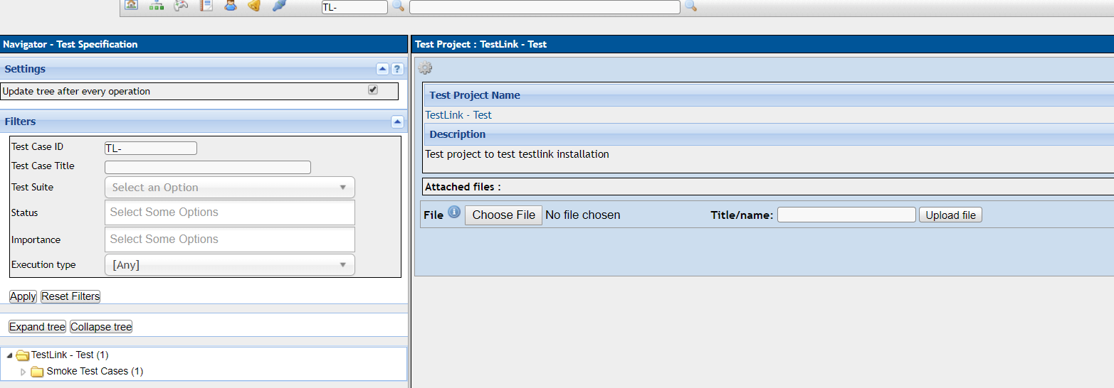

##### Create a Test Suite

Following are the steps to create a Test Suite −

**Step 1** − Navigate to Test Specification → Test Specification from the dashboard.

**Step 2** − Click the Setting type icon Symbol known as Actions on this page, present on the right panel as shown in the following screenshot. It will open Test Suite Operations.

**Step 3** − Click the + icon to create a new suite as shown below.

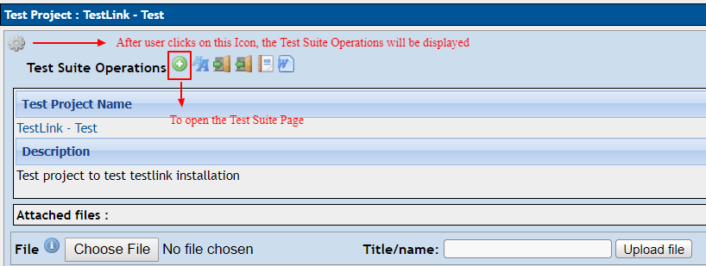

**Step 4** − Enter the following fields in the form −Name of Test Suite and Details

**Keywords** − It displays all the available keywords. You can assign them based on relation.

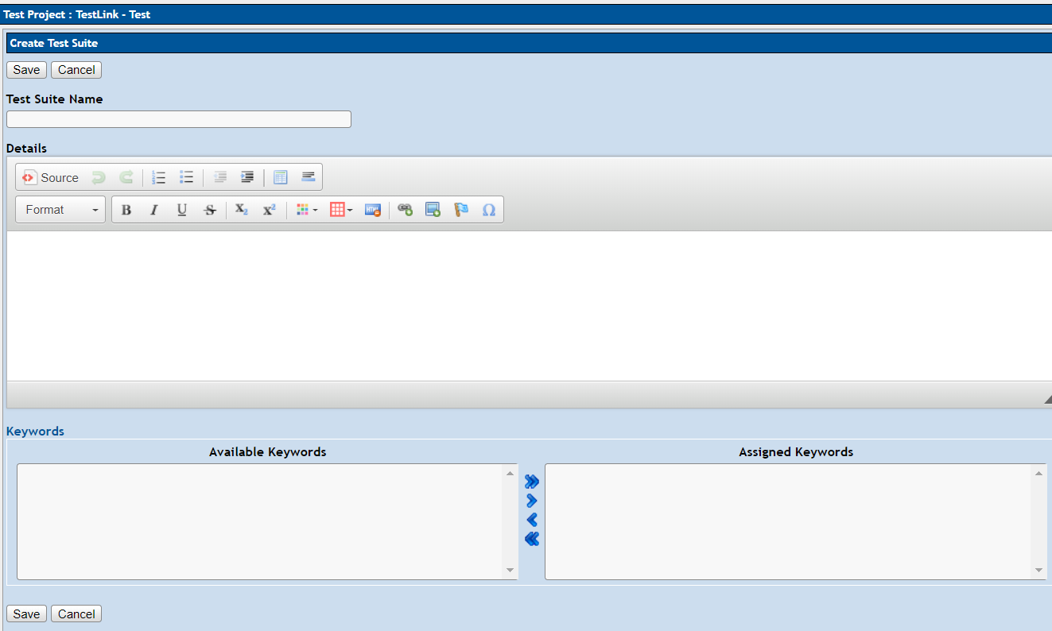

Once you add the required details and click Save, you will see the test suite in tree structure on the left side panel of the screen. The details are available on the right side of the screen.

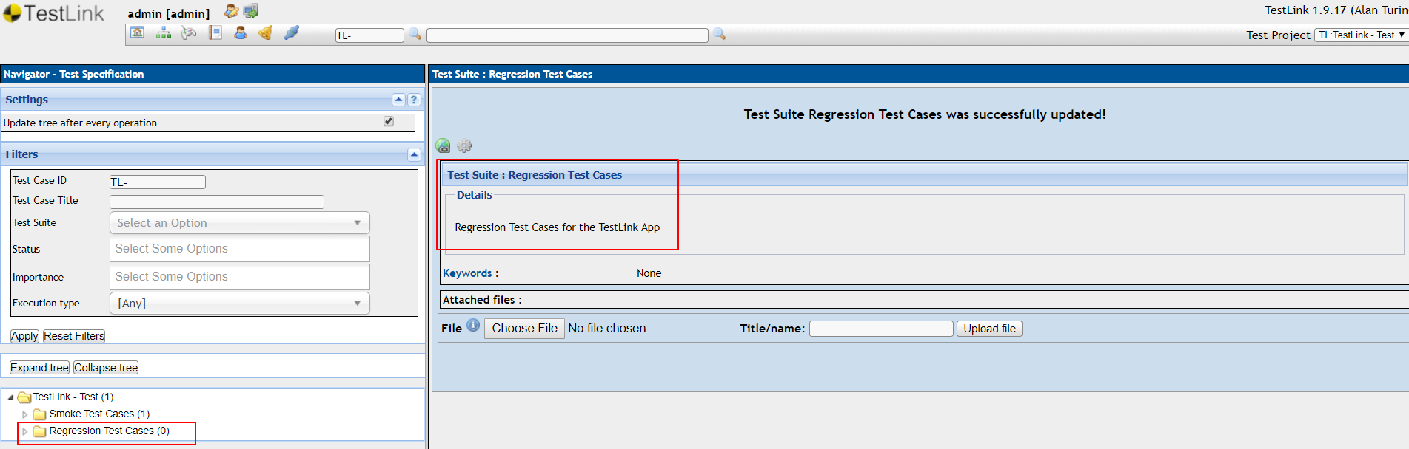

On clicking the Setting type icon Symbol , you can edit, copy, move, delete the Test Suite, as and when required.

##### Create a Test Case

To create a Test Case, you should have Create Test Cases permission. Following are the steps to create a Test Case −

**Step 1** − Navigate to Test Specification → Test Specification from the dashboard.

**Step 2** − Select the test suite from the tree structure on the left side panel on the screen.

**Step 3** − Click the Setting type icon known as Actions on this page, present on the right panel of the screen as shown below.

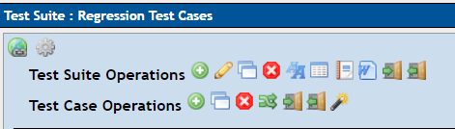

It will open Test Suite Operations as well as Test Case Operations.

**Step 4** − Click the + icon of Test Case Operations to create a new test case as shown below.

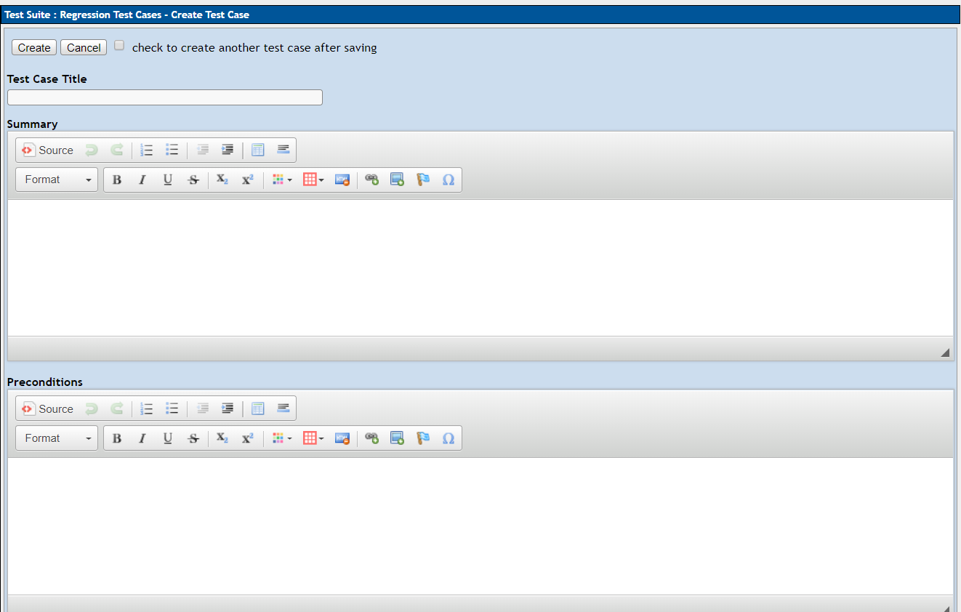

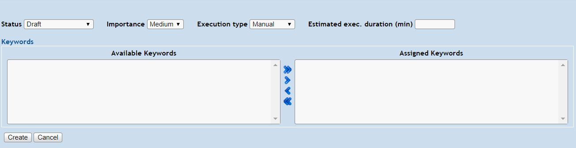

**Step 5 -** Enter the required details and click on the ‘**Create**’ button.

Test Case will get created and will be displayed in the left panel, below the respective Test Suite. 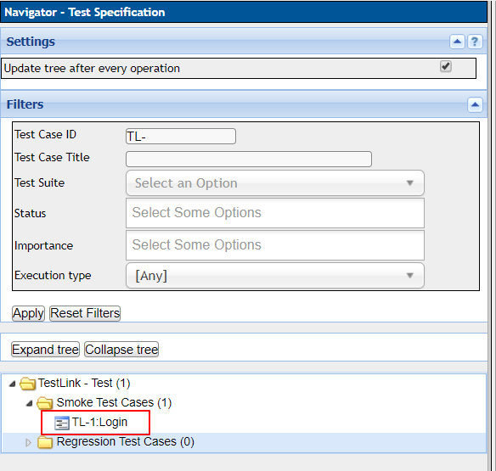

On clicking on the Test Case option above, the test case along with its detail will be viewed in the right side paned, from where it can be edited, copied, moved, create new version or deleted as required.

**Note –** An executed test case will not have the delete option available, for such test cases you can create a new version of the test case, that can be used or move it to a Test Suite that is obsolete and no longer in use.

### Test Execution Management

##### Assignment of Test Cases

**Step 1** − Go to Test Plan contents → Assign test cases execution from the dashboard as shown below.

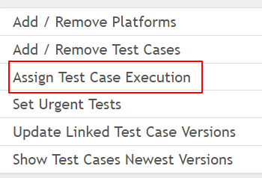

**Step 2** − On the left side of the screen, search the test suite and click it. It displays the details and test cases present on the right side.

**Step 3** − Select the test case to be assigned. Verify if any existing user is present. The ‘Assigned To’ field displays the user name if it is assigned.

**Step 4** − Go to Assign text box and start typing the name of the user. It will display the list of matched users, from which you can select the user name.

**Step 5** − Click the Save button present at the top of the screen. After assigning the test case, the user name appears in the Assigned to section along with a red symbol.

**Step 6** − If the assigned user needs to be removed, simply click the red symbol Red Symbol, it will remove the assigned user.

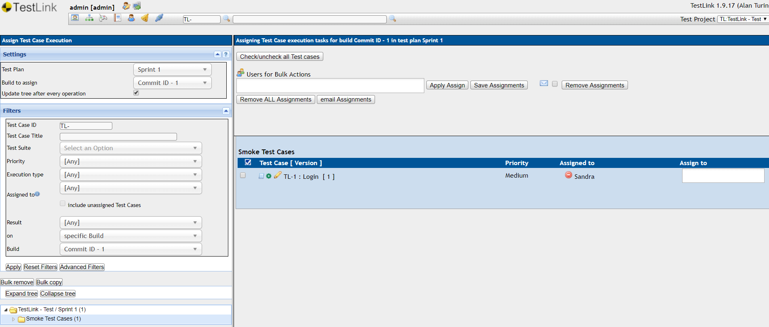

##### Executing Test Cases

**Step 1** − Go to Test Execution → Execute Tests from the dashboard as shown below.

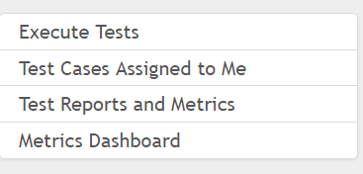

It opens Execute Test page where Settings and Filters are present on the left panel.

Along with these two, there is a tree menu as well.

**Step 2** − Select Test Plan and build at the setting section.

**Step 3** − In the filter section, you can narrow down the tree structure present below the filter.

Following screenshots displays Navigation & Settings in execute tests page

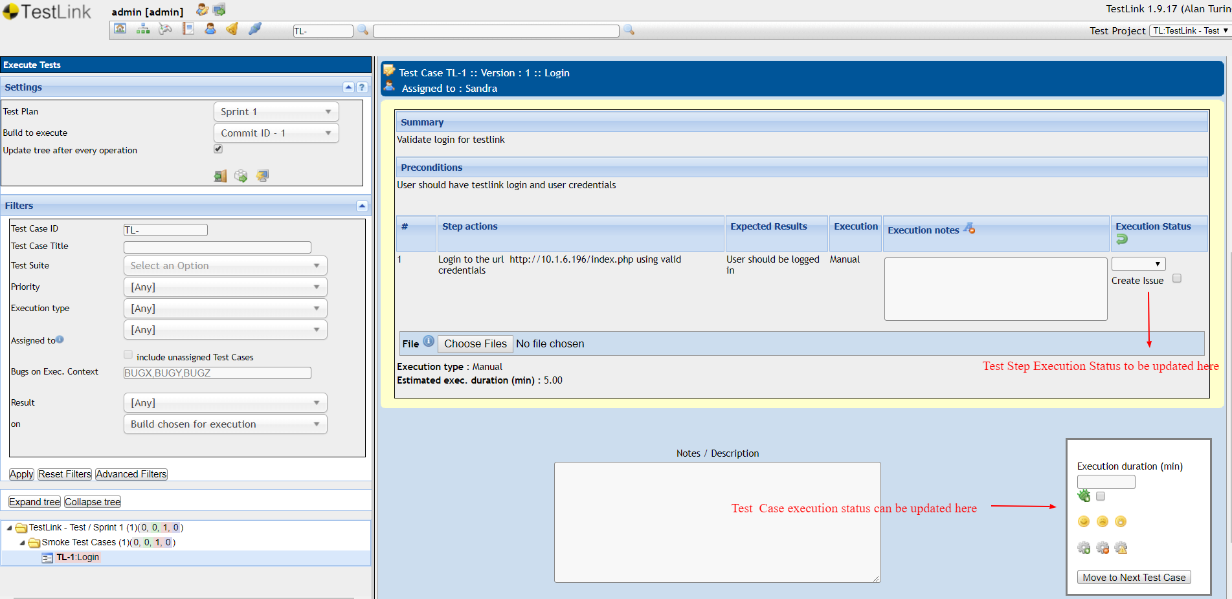

If a test case execution is marked to Failed, you can link the execution to a defect created in JIRA

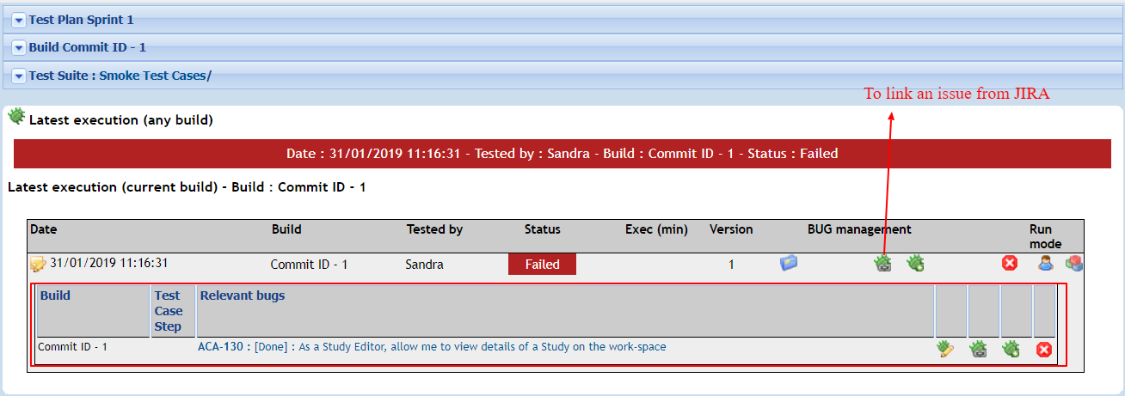

On clicking the link defect icon, it would open a window as displayed in the below image, where you can add the defect id from JIRA and link the defect to the failed execution. Once the defect is linked, it will start showing up against the execution, as displayed in the above image.

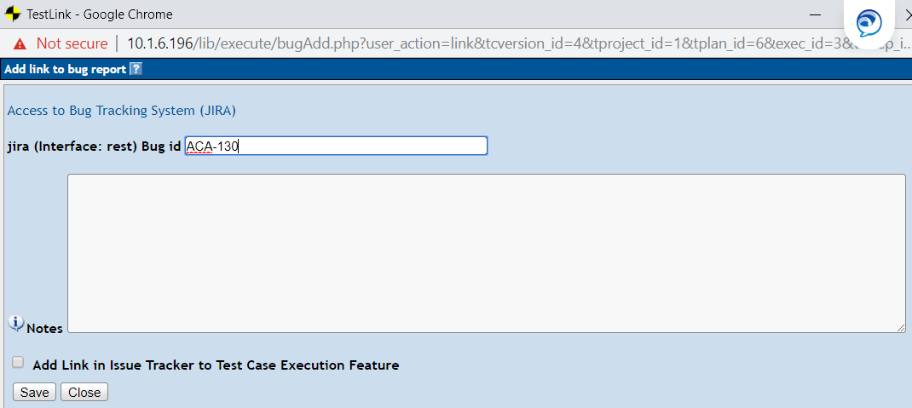

To check the test case executions assigned to you, you can also click on the ‘**Test Cases Assigned to me**’ from the dashboard



On click of which the user will be navigated to the below screen

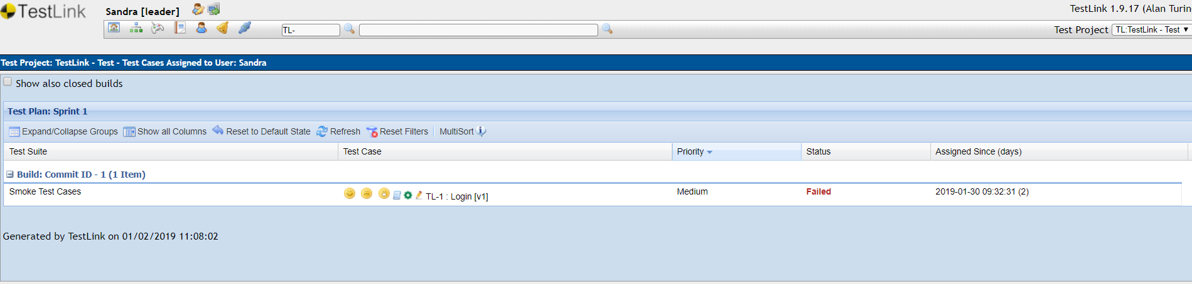

You set test case execution results here, open the execution window, edit the test case or check test case matrices from this section. It also shows the status and last execution time stamp for the test case.

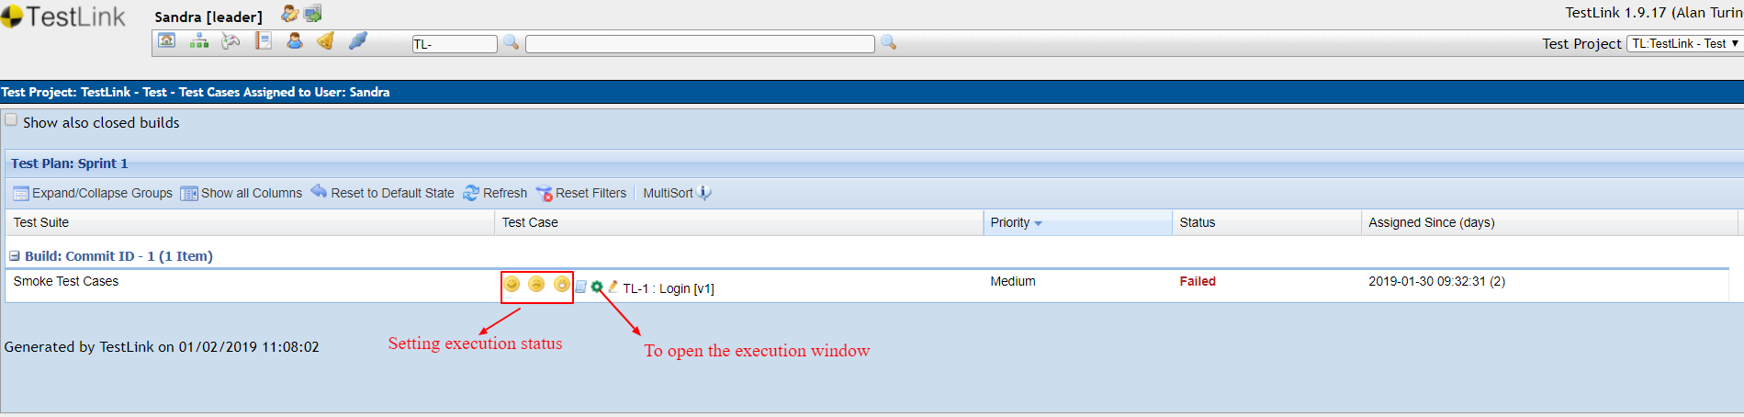

### Test Reports

Reports and Metrics group the results of execution at one place that helps to track the progress of the project.

To access the Report and Metrics section, select Test Execution → Test Reports and Metrics from the dashboard as shown below.



The left pane is used to navigate to each report and operate controls of reports behavior and display. The button “Print” initializes the printing of the right pane (no navigation will be printed).

You can print as HTML or Pseudo MS Word. You can also email the report in HTML format. The right pane displays a summary of each report.

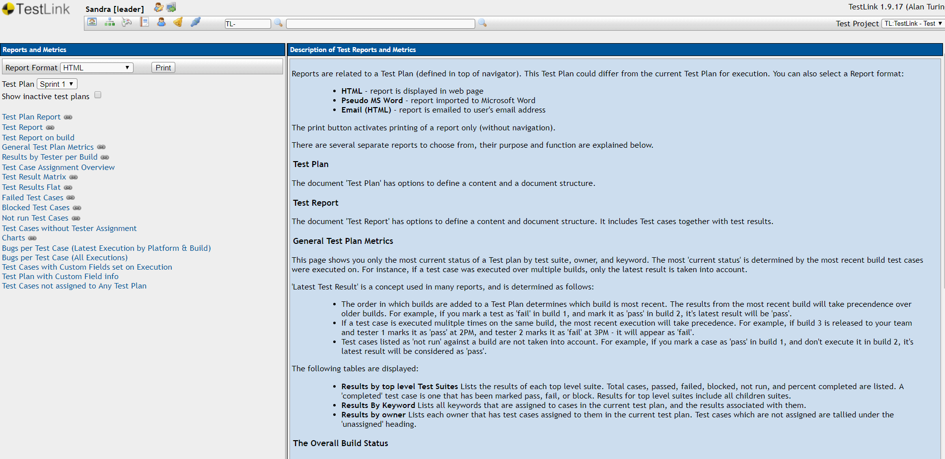

##### Test Result Matrix

This report displays all the currently blocked, failed, passed or not run Test Cases. It shows the last test case execution result for each build. In addition, the last column shows the last test case execution result for the last created build.

“Last Test Result” logic (which is described above under General Test Plan Metrics) is used to determine if a Test Case should be considered blocked, failed, passed or no run.

Blocked and failed Test Case reports will display the associated bugs if the user is an associate of integrated bug tracking system with TestLink.

To access the Test Result Matrix, click the Test Result Matrix on the left pane. it displays the report on the right side as shown in the following screenshot.

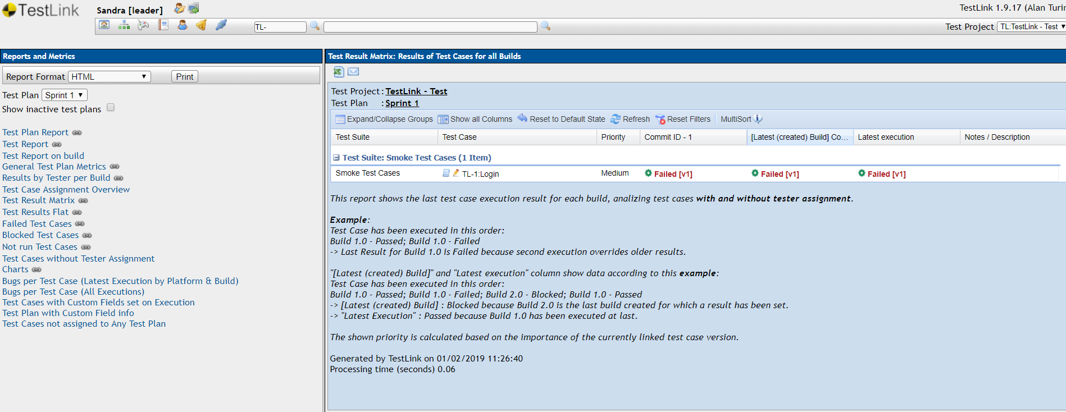

##### General Test Plan Metrics

These metrics display the status of a Test Plan by the following criteria - test suite, owner, milestone, priority and keyword. In addition to this, it also displays the basic metrics for all enabled builds. The current status is determined by the recent Build where Test Cases are executed.

For instance, if a Test Case is executed in multiple builds, only the latest result is counted. Last Test Result is a concept used in many reports, and is determined as follows −

The order of Builds is created into a Test Plan. For example, if a test fails in Build 1, and is marked as pass in Build 2, the latest result will pass.

If a Test Case is executed multiple times on the same Build, the most recent execution will be considered. For example, if Build 3 is released and marked as “pass” at 1PM and marked as “fail” at 5PM – will be considered as fail.

Test Cases listed as “No Run” in a Build is not considered. For example, if a test case is marked as “pass” in Build 1 and don't execute in Build 2, the last result will be considered as “pass”.

When you click General Test Plan Metrics on the left side of the screen, it displays all the results as shown below.

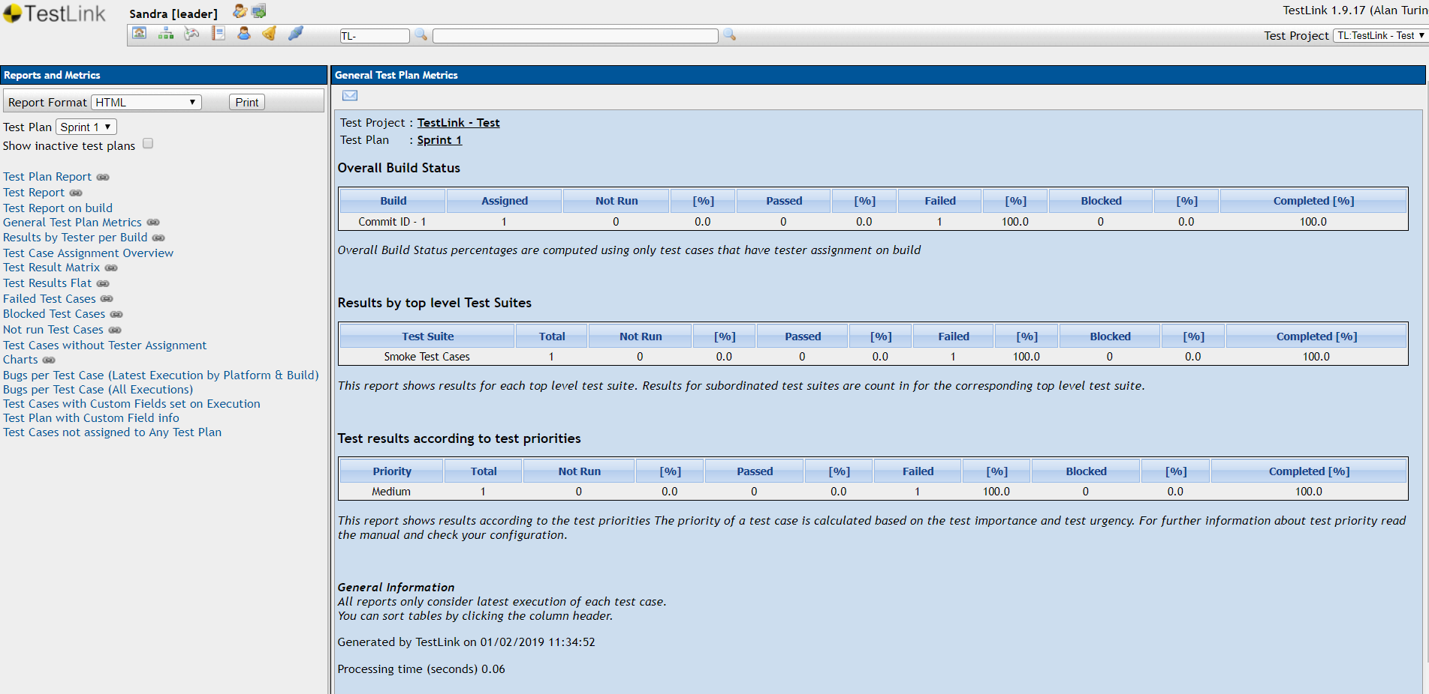

##### Failed Test Case Report

This report displays the failed test cases along with the linked defects.

